User Manual
Department General Form
District GIS Parakh
Creating, Launching, Assigning (One-Time), Filling & Reporting on Department General Forms
Example used throughout: रबी फसल विपणन (Rabi Crop Procurement Centre Inspection)
Version 1.0 | 24-Aug-2026
Madhya Pradesh State Electronics Development Center (MPSeDC)
State IT Center, 47-A, Arera Hills, Bhopal, M.P. – 462011

Document Information
Property | Value
Document Title | District GIS Parakh — Department General Form: User Manual
Project | District GIS Parakh, MPSSDI / MPSeDC
Version | 1.0
Date | 24-Aug-2026
Prepared By | Dheeraj Motiyani, Senior Business Analyst, MPSeDC (MPSSDI)
Sources | Parakh General Manual (Functional Flow — Form & Asset Creation) v1.0, 06-Oct-2025; District GIS Parakh Consolidated Bilingual User Manual v2.4; live UAT screenshots (Bhopal Collectorate / Indore Collectorate), Aug-2026
Scope Note | This manual covers ONLY the Department General Form type. For Data Collection, Inspection, Survey, Sudden Inspection, and Citizen/General forms, refer to the Data Collection Form manual and the Consolidated Bilingual User Manual.

1. What is a Department General Form?
Form Type (Step 3 of Create Form) | Used For
Data Collection / Survey Form (Daily/Frequent) | For Inspectors collecting recurring data on the same asset over time (see the separate Data Collection Form manual).
Department General Form | For department-level inputs — the subject of this manual.
Citizen General Form | Open for all citizens (public-facing feedback/requests).
Inspection Form | Linked with Data Collection, but for one-time surveys.
Form Name | Status
विद्यालय मॉनिटरिंग प्रपत्र (School Monitoring Form) | Active
जनजातीय छात्रावास निरीक्षण प्रपत्र (Tribal Hostel Inspection Form) | Inactive
रबी फसल विपणन (Rabi Crop Marketing) — worked example used in this manual | Active
शाला निरीक्षण प्रपत्र (School Inspection Form) | Inactive
NOTE: Assignment is where Department General Forms most clearly differ operationally from Data Collection Forms: a Department General Form is assigned for one-time inspection/survey only — there is no Frequency (Monthly/Quarterly/etc.) option for it. If the same activity needs to repeat on a schedule, it should be created as a Data Collection form instead, not a Department General form.

2. Roles & Responsibilities
Role | Responsibility for Department General Forms
State Admin | Creates the Department General Form (Section 3), configures its questions (Section 4), and can view all launched forms, assignments, and reports.
Department Admin / Nodal Officer | Creates department-specific General forms where delegated; approves/rejects field users before they can be assigned one-time survey work.
Reporting Officer | Assigns the form to Inspectors for a one-time inspection/survey (Section 5); reviews and verifies submitted data (Section 7).
Inspector | Conducts the one-time inspection against the assigned site/asset and submits it from the mobile app (Section 6).

3. Creating a Department General Form (Web — State Admin)
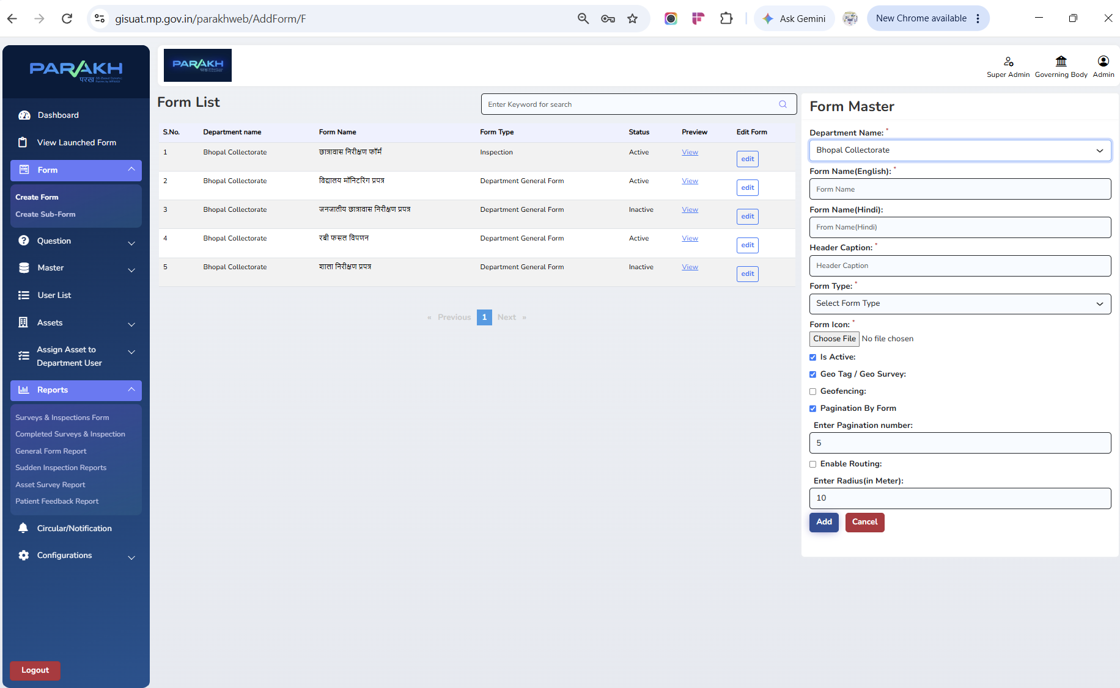
Screen — Form List (left) for Bhopal Collectorate, showing four forms already configured as 'Department General Form' — विद्यालय मॉनिटरिंग प्रपत्र, जनजातीय छात्रावास निरीक्षण प्रपत्र (Inactive), रबी फसल विपणन, शाला निरीक्षण प्रपत्र (Inactive) — alongside one Inspection-type form; and the Form Master panel (right) for creating a new form.
Field | Purpose
Department Name | The department this form belongs to (e.g. Bhopal Collectorate).
Form Name (English) | The form's display name in English.
Form Name (Hindi) | The form's display name in Hindi, e.g. "रबी फसल विपणन".
Header Caption | Short heading shown at the top of the form on mobile/web.
Form Type | Select "Department General Form" from the dropdown — this marks the form as one-time, department-level input rather than a recurring Data Collection form.
Form Icon | Upload an icon image shown against the form on mobile.
Is Active | Must be checked for the form to be usable; unchecking retires it (e.g. जनजातीय छात्रावास निरीक्षण प्रपत्र and शाला निरीक्षण प्रपत्र are currently Inactive).
Geo Tag / Geo Survey | Enable to require a geo-tagged location capture as part of every submission.
Geofencing | Enable to restrict submission to within a defined radius of the site's registered location.
Pagination By Form | Enable to split a long form into pages; "Enter Pagination number" sets how many questions appear per page (e.g. 5).
Enable Routing | Enable to turn on map-based routing to the site; "Enter Radius (in Meter)" sets the buffer distance used when routing (e.g. 10).
- Click Add to save the form once all required (*) fields are filled.
- The new form immediately appears in the Form List with Status = Active and a View link to preview it.

4. Building the Form's Questions — Worked Example: रबी फसल विपणन (Rabi Crop Marketing)
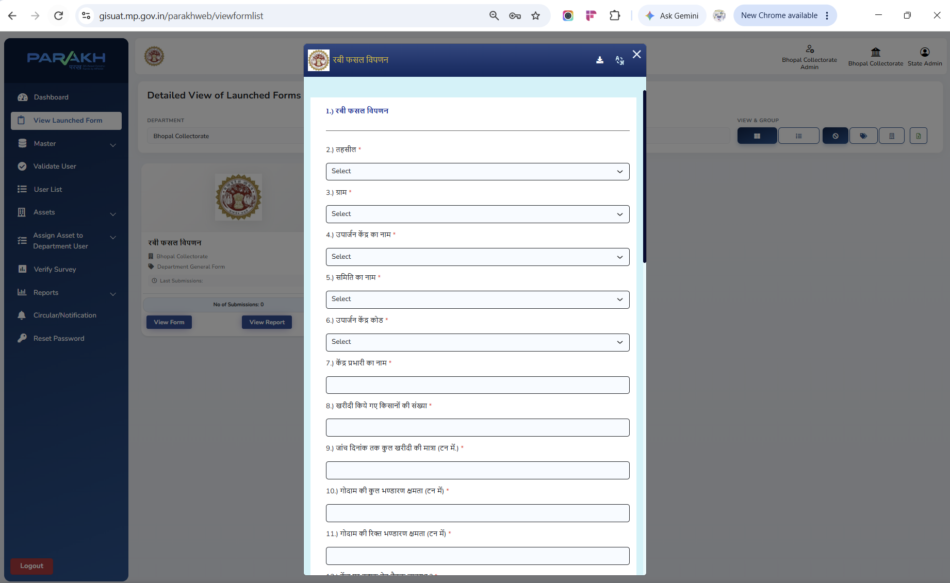
Screen — रबी फसल विपणन (Rabi Crop Marketing) form preview, showing the question sequence from Tehsil selection through warehouse capacity.
Question | Field Type
तहसील (Tehsil) | Dropdown — cascades from the selected district.
ग्राम (Village) | Dropdown — cascades from the selected Tehsil.
उपार्जन केंद्र का नाम (Procurement Centre Name) | Dropdown, selected from the master list of registered centres.
समिति का नाम (Committee Name) | Dropdown — the cooperative/marketing committee operating the centre.
उपार्जन केंद्र कोड (Procurement Centre Code) | Dropdown/master-linked code identifying the centre.
केंद्र प्रभारी का नाम (Centre In-Charge Name) | Text entry.
खरीदी किये गए किसानों की संख्या (No. of Farmers Purchased From) | Numeric entry.
जांच दिनांक तक कुल खरीदी की मात्रा (टन में) (Total Quantity Purchased till Inspection Date, in Tons) | Numeric entry.
गोदाम की कुल भंडारण क्षमता (टन में) (Total Warehouse Storage Capacity, in Tons) | Numeric entry.
गोदाम की रिक्त भंडारण क्षमता (टन में) (Vacant Warehouse Storage Capacity, in Tons) | Numeric entry.
(further questions continue below the fold, e.g. availability of weighing/cleaning equipment) | Various — Yes/No, text, numeric.
NOTE: Notice that this form has no beneficiary-count-by-visit pattern the way a recurring Data Collection form does — it captures the procurement centre's status as of one inspection date. That is the structural signal that Department General Form is the correct type for this kind of one-time survey.

5. Assigning a Department General Form — One-Time Inspection & Survey
1. Select Department — Choose the Department from the dropdown (e.g. Bhopal Collectorate).
2. Select District & Tehsil — Choose the District and, optionally, the Tehsil.
3. Select Form — Choose रबी फसल विपणन (or the relevant Department General Form) as the form under which the work will be assigned.
4. Select Department User — Choose the Inspector/officer who will carry out this one-time inspection.
5. Filter by Allotment Status — Use the Is Allotted filter: Yes = centres already assigned; No = centres still pending assignment.
6. Assign & Save — Select the required procurement centres (assets) and confirm assignment. The officer will see them in the mobile app as work to complete once — there is no repeat cycle to track for this assignment.

6. Viewing Launched Forms
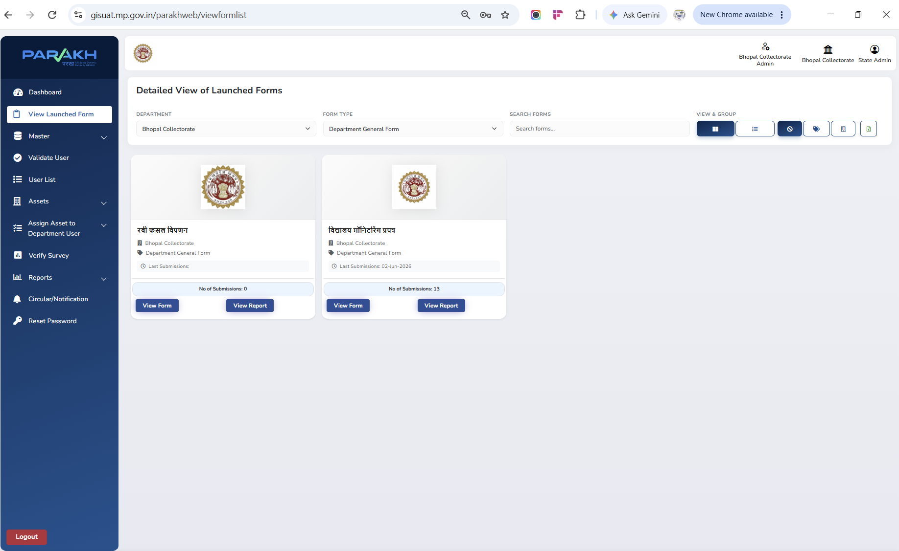
Screen — View Launched Form, filtered to Department = Bhopal Collectorate, Form Type = Department General Form. Each card shows the form name, last submission date, and total submission count, with direct View Form and View Report buttons.
- Filter by Department and Form Type (e.g. Department General Form) to narrow the list, or use Search Forms to find a specific form by name.
- Each card shows No. of Submissions and Last Submissions date at a glance — रबी फसल विपणन shows 0 submissions (not yet used in the field) while विद्यालय मॉनिटरिंग प्रपत्र shows 13 submissions, last received 02-Jun-2026.
- View Form opens a live preview of the form; View Report jumps directly into that form's General Form Report (Section 7).
- The View & Group icons on the top-right let the State Admin switch between card, list, and other groupings of the same launched-forms list.

7. Filling the Form (Mobile — Inspector)
- The Inspector logs into the Parakh mobile app and opens New Modules (or their assigned-work list), where रबी फसल विपणन appears alongside any other Department General or Inspection forms assigned to them.
- The Inspector selects the assigned procurement centre, which opens the same map/pin flow used for other form types.
- The Inspector fills the questions from Section 4 — Tehsil, Village, Centre details, farmer/quantity counts, and warehouse capacity — capturing photos and GPS location as configured.
- Save as Draft is available if the visit cannot be completed in one sitting; Submit finalises the record.
- Because this is a one-time form, once submitted the assignment for that centre is complete — it does not automatically reappear for a future cycle the way a Data Collection form does.

8. Reports — General Form Report
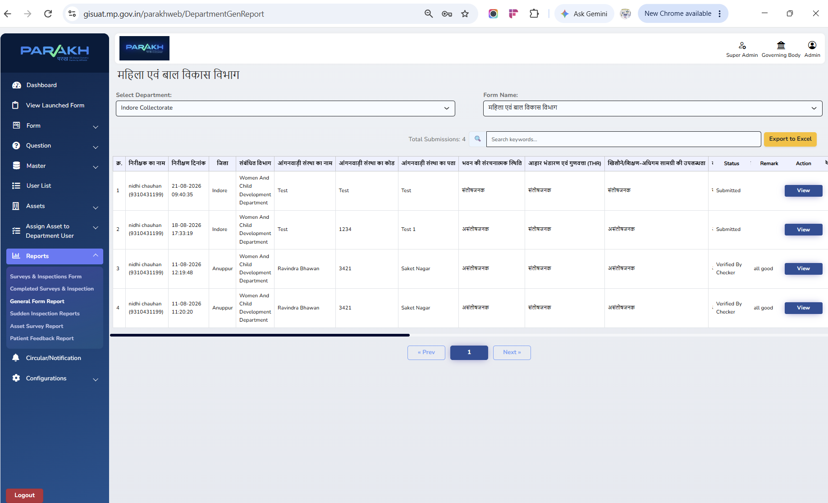
Screen — General Form Report for महिला एवं बाल विकास विभाग (WCD), Indore Collectorate — Anganwadi-related Department General submissions, showing inspector, date, district, centre details, condition ratings, and a Status column with values Submitted and Verified By Checker plus a Remark and View action.
- Select Department (e.g. Indore Collectorate) and Form Name (e.g. महिला एवं बाल विकास विभाग) to load that form's submissions.
- Total Submissions is shown alongside a keyword Search box and Export to Excel.
- The Status column reflects this form type's review workflow: Submitted (awaiting review) progresses to Verified By Checker once a supervisor has checked it, and a Remark can be recorded against the record (e.g. "all good").
- The View action on each row opens the full submitted form for that record.
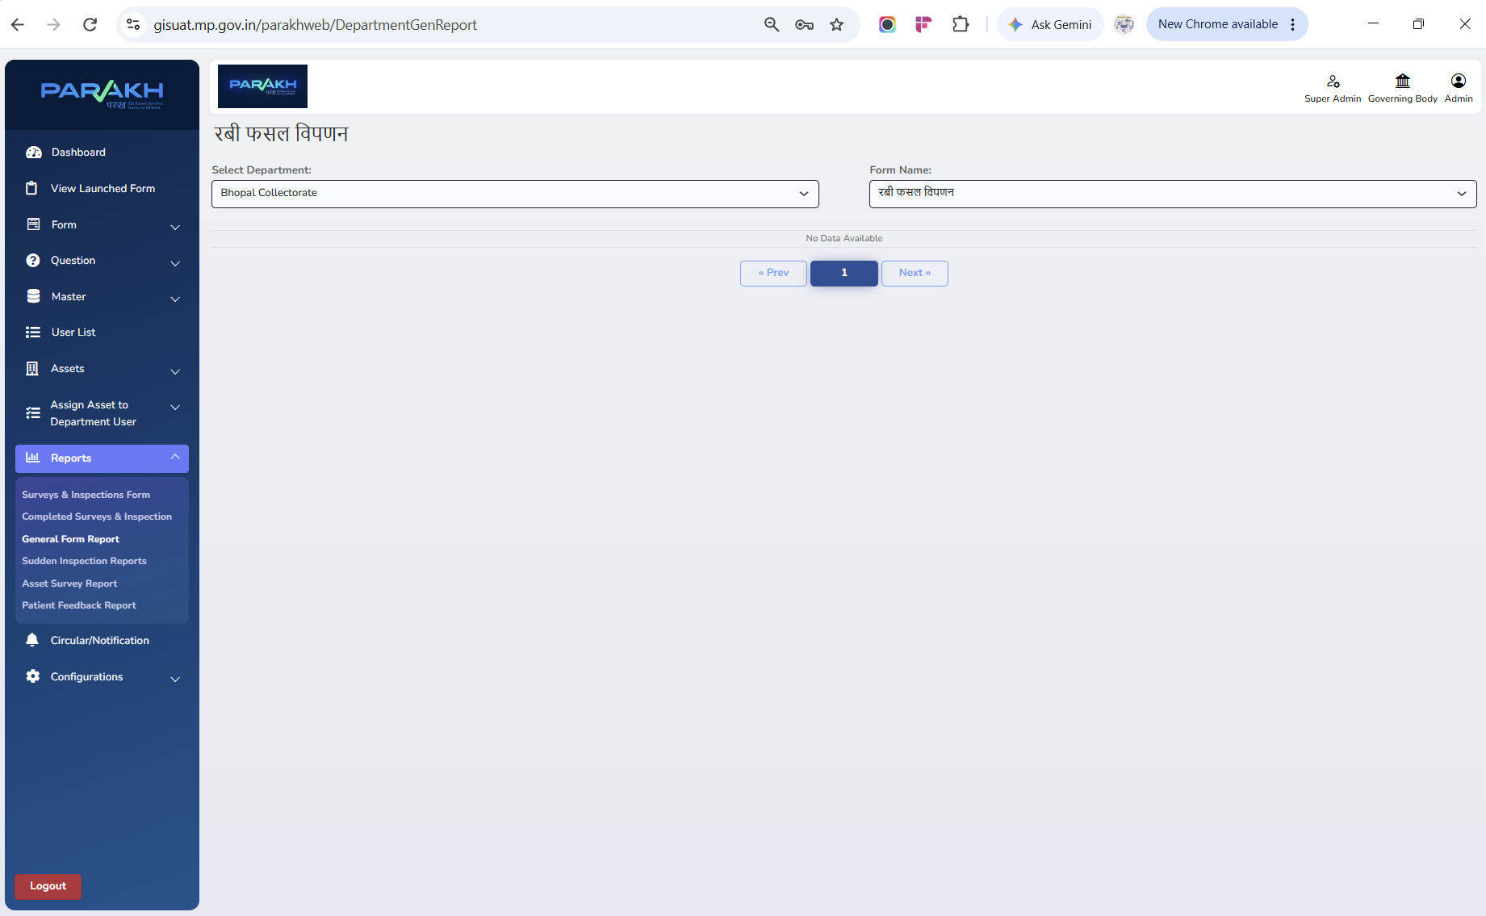
Screen — General Form Report filtered to रबी फसल विपणन (Bhopal Collectorate), showing the 'No Data Available' empty state — consistent with the 0 submissions shown for this form on the View Launched Form screen (Section 6).

9. Validation & Exception Handling
- Mandatory fields must be completed before a submission is accepted.
- Duplicate entries are flagged by the system.
- Invalid/unauthorised user attempts are logged.
- If survey data is incomplete, the system prompts the Inspector to re-enter it before submission.
- If a user is not yet approved, they cannot access or fill any Department General Form.
- If there is a network failure mid-submission, data is stored on the device and synced automatically once connectivity is restored.

10. Compliance Note

